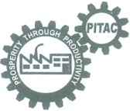 | Pakistan Industrial Technical Assistance Centre (PITAC), Lahore  Ministry of Industries & Production  Government of Pakistan
Training Course on CNC Turning Center
Key Points / Course Outline (Theory):-  - Introduction and Programming Techniques  - Programming by using G and M Codes  - Tool Compensation Techniques  - Selection of Cutting Tools  - Calculation of Cutting conditions  - Off-Setting the Cutting Tools  - Execution of Programme  - Job Inspection & Reflection  - Adjustment of tool offset on tool wear  - Manual Facing and Turning Program  - Introduction to Canned Cycles  - Rough Turning Canned Cycle (G71)  - Rough Facing Canned Cycle (G72)  - Finishing Canned Cycles (G70)  - Drilling Canned Cycle (G74)  - Grooving Canned Cycle (G75)  - Threading Canned Cycle (G92  - Taper Threading  - Fine Threading Canned Cycle (G76)  Boring/Internal Turning Canned Cycle (G71)  Use/Practice of SwanSoft for making complete programs and simulations | 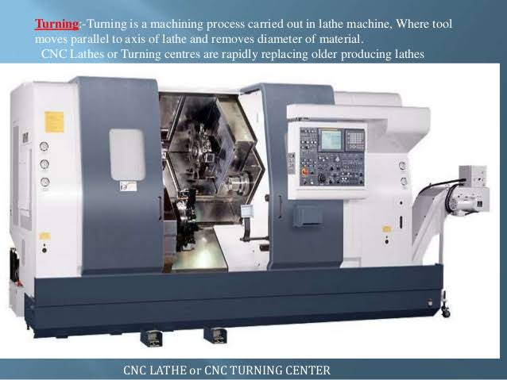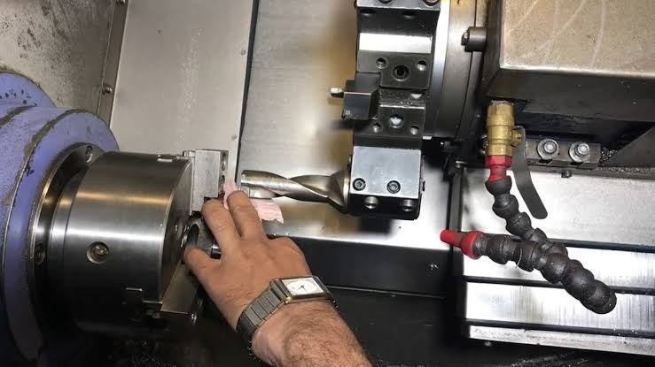
- 100% Practical Oriented
- Limited Seats
- Qualification: Middle or above
- Duration: 06 Weeks (Mon ~ Fri)
- Timing: 4:00 PM to 6:30 PM
- Course Fee: Rs. 10000/-

If you wish to Learn the New Trend of CNC Programming from Basic to Professional with Us. If you Want to Learn Industry Level Programming. in short Span of time. Then join us:
PITAC, 234-Ferozepur Road (Near Canal Metro Station), Lhr.
Ph: 042-99230701 Ext. 844
Contact Instructor: Muhammad Atif, 0321-4940457

