GOVERNMENT OF PAKISTAN
MINISTRY OF INDUSTRIES & PRODUCTION
PAKISTAN INDUSTRIAL TECHNICAL ASSISTANCE CENTRE (PITAC)
<<<<o>>>>

Subject: MATERIAL FOR YEAR BOOK FOR FISCAL YEAR 2018-2019

PITAC is an Autonomous organization established in 26th May, 1962 with the merger of Industrial Research and Development Centre (IRDC) and Industrial Productivity Centre (IPC) under the administrative control of Ministry of Industries and Production, Government of Pakistan and registered under the Societies Registration Act, 1860 vide Gazette Notification of Pakistan Resolution No. C&P-9(11)/62 dated 26th May, 1962, with the mandate to increase the productivity of industrial units in the country, introducing improved productive techniques, and providing organized and nationwide programs for training of Managerial and Technical personnel.
The progress of PITAC during the fiscal year 2018-19 is as follows:
- TECHNICAL AND MANAGERIAL SKILL DEVELOPMENT SERVICES
Sr. No. | Output(s) | Indicators | 2018 – 19
1 | Provision of Technical and Managerial Training Services to Public and Private Sector Organizations, Industries, Industrial Personnel and Individuals | No. of Courses conducted in Technical and Managerial Training Fields | 251
2 |  | No. of Trainees Trained in Technical and Managerial Training Fields | 2055
3 |  | No. of Workshop / Seminars / Symposiums organized in Technical and Managerial Training Fields | 72
4 |  | No. of Participants participated in Workshop / Seminars / Symposiums of Technical and Managerial Training Fields | 2525
5 |  | No. of Courses / Workshop / Seminars / organized for Entrepreneurship Development | 09
6 |  | No. of Participants participated in Courses / Workshop / Seminars / organized for Entrepreneurship Development | 1490
7 |  | No. of Technical Personnel trained under Apprenticeship Training Program (For Engineers, DAEs and Technicians) and Internship Training Program (For University / College Students) | 68
8 |  | No. of Technologists produced under Technical Education Program of Three (03) Year Diploma of Associate Engineer (DAE) in PITAC College of Technology (PCT) | 293
 | Total Number of Courses in Technical and Managerial Fields, Technical Education and Entrepreneurship Trainings |  | 332
 | Total Number of Trainees in Technical and Managerial Fields, Technical Education and Entrepreneurship Trainings |  | 6431

- TECHNOLOGICAL BACK UP SUPPORT AND ADVISORY SERVICES
SME’s and Industry are being benefitted by PITAC through its Technological Back up Support & Advisory Services:
Sr. No. | Output(s) | Indicators | 2018 -19
1. | Provision of Technical Support and Advisory Services to Industry. | Computer Aided Designing (CAD) of Engineering Products, Precision Parts, Prototypes & Production Toolings (Incl. Dies, Molds, Jigs, Fixtures, Precision Inspection Gauges etc.) – In Nos. | 236
2. |  | Computer Aided Machining (CAM) of Engineering Products, Precision Parts, Prototypes & Production Toolings (Incl. Dies, Molds, Jigs, Fixtures, Precision Inspection Gauges etc.) – In Nos. | 390
3. |  | Reverse Engineering of Engineering Products, Precision Parts, Prototypes & Production Toolings (Incl. Dies, Molds, Jigs, Fixtures, Precision Inspection Gauges etc.) – In Nos. | 70
4. |  | Conventional Machining of Engineering Products, Precision Parts, Prototypes & Production Toolings (Incl. Dies, Molds, Jigs, Fixtures, Precision Inspection Gauges etc.) – In Nos. | 1078
5. |  | Inspection Services of Engineering Products, Precision Parts, Prototypes & Production Toolings (Incl. Dies, Molds, Jigs, Fixtures, Precision Inspection Gauges etc.) – In Nos. | 903
6. |  | Heat Treatment of Engineering Products, Precision Parts, Prototypes & Production Toolings (Incl. Dies, Molds, Jigs, Fixtures, Precision Inspection Gauges etc.) – In Nos. | 386
7. |  | Super Finishing of Engineering Products, Precision Parts, Prototypes & Production Toolings (Incl. Dies, Molds, Jigs, Fixtures, Precision Inspection Gauges etc.) – In Nos. | 370
8. |  | Tool Room Machining (TRM) of Engineering Products, Precision Parts, Prototypes & Production Toolings (Incl. Dies, Molds, Jigs, Fixtures, Precision Inspection Gauges etc.) – In Nos. | 706
9. |  | Advisory Services extended to the Industries | 12
 | Total Number of Engineering Products, Precision Part, Prototypes & Production Tooling developed and Advisory Services Extended |  | 4151

- HIGHLIGHTS OF OTHER ACTIVITES BY PITAC IN FY- 2018-19.
- APPLIED ENTREPRENUERSHIP THINK AND GROW CONFERENCE.
Pakistan Industrial Technical Assistance Centre (PITAC) has organized an International conference on “Applied Entrepreneurship Think and Grow” on 30th March, 2019. The said international conference was chaired by Mr. Abdul Razzak Dawood (Advisor to Prime Minister for Industry, Commerce, Textile, Production and Investment). This conference was attended by professional experts, Industrialists and Entrepreneurs who shared their knowledge and experience to provide a direction for the students both from Pakistan and abroad who have participated in the conference. The students also have participated in the Entrepreneurship Completion and shared their ideas. The 1st, 2nd and 3rd position holder were also given the monetary rewards for implementation of the ideas.
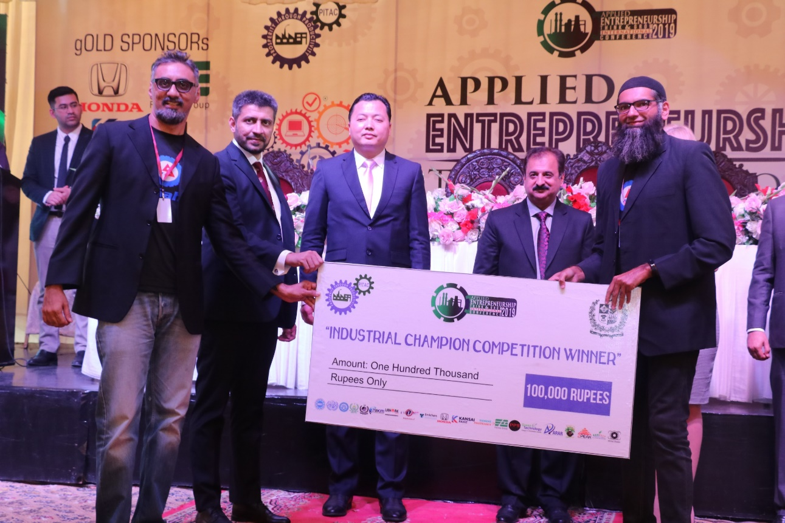
Project Name: Auto Sahulat by University of Central Punjab (UCP)
1st Position
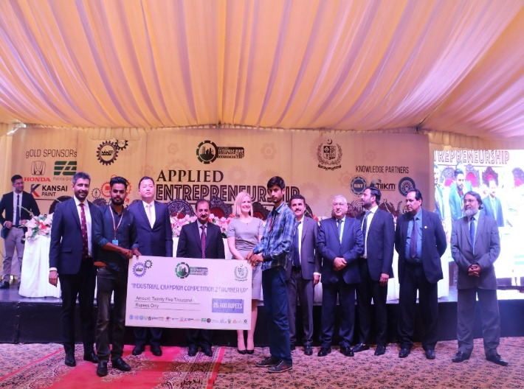 | 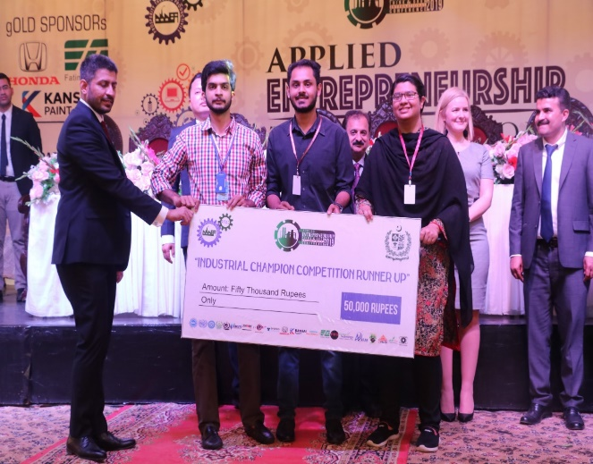
Project Name: CNC Machine by PITAC College of Technology (PCT)  2nd Runner up | Project Name: Code Ranker by University of Management & Technology (UMT)  1st Runner up

- SPEAKERS & DIGNITARIES:
The speakers and dignitaries who invited the Applied Entrepreneurship think and Grow Conference was as follows:
- Mr. Abdul Razzak Dawood Advisor to Prime Minister for Industry, Commerce, Textile, Production and Investment
- Mr. Waleed Iqbal (Honorable Senator)
- Dr. Cui Yong (Dy. Sec. General Belt & Road / Vice Dean Jiangsu University, China)
- Dr. Dragana Ostic (Assistant Professor Jiangsu University)
- Dr. Muhammad Aslam (Rector, UMT)
- Dr. Abid Sherwani (Director General, UMT)
- Dr. Muqeem Ul Islam (Director General NAVTTC
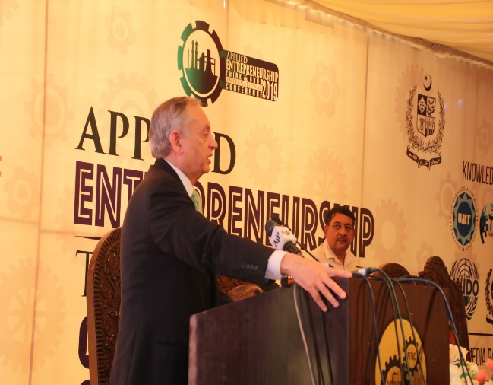 | 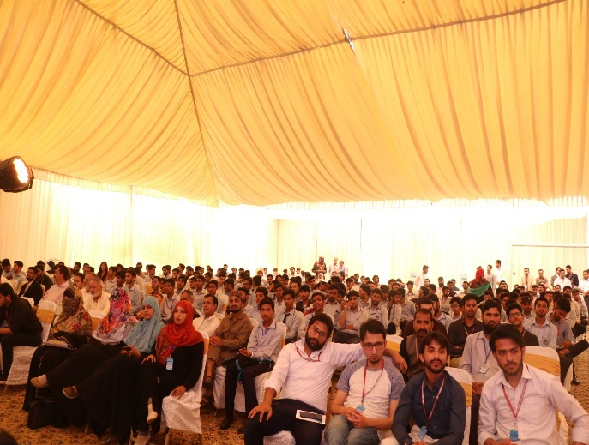
Mr. Abdul Razzak Dawood Advisor to Prime Minister for Industry, Commerce, Textile, Production and Investment addressing the participants.
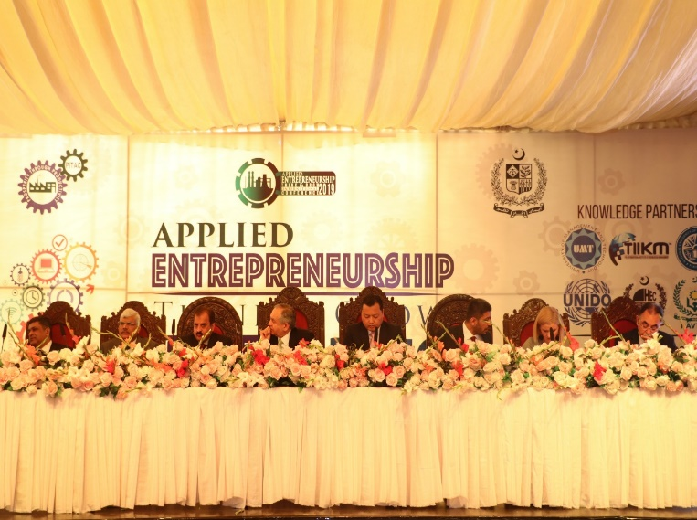 |  | 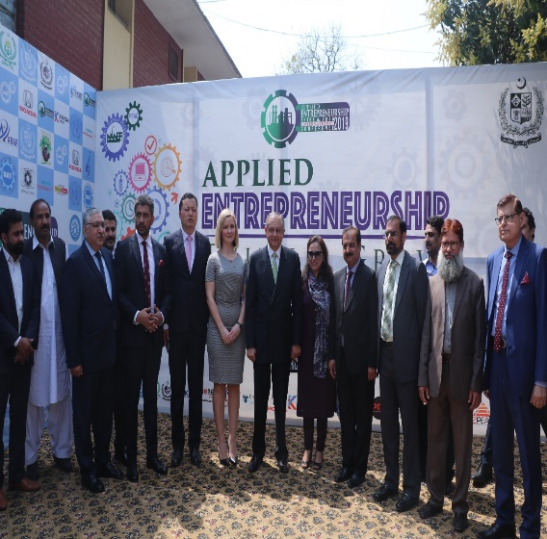
Speakers & Dignitaries

- THE KEY POINTS AND THEME OF THE CONFERENCE WAS AS FOLLOWS:
- Role of Technical Vocational Entrepreneur Training (TVET) in Applied Entrepreneurship
- Belt and Road Startup Accelerator Innovative Entrepreneurship
- Opportunities and Challenges for Entrepreneurial Start-Ups at China Pakistan Economic Corridor (CPEC)
- Information Technology and E-commerce
- Industry, Innovation and Infrastructure Entrepreneurial Ventures
- INAUGURATION OF ENTREPRENEURSHIP TRAINING AND DEVELOPMENT DEPARTMENT.
- Pakistan Institute of Entrepreneurship Training (PIET) was merged with PITAC in April 1997.
- Revival as Entrepreneurship Training and Development Department (ETDD) in HQ Lahore and Entrepreneurship Training and Development Cells (ETDC) in Regional Centre(s).
- Inaugurated by Mr. Abdul Razzak Dawood Advisor to Prime Minister for Industry, Commerce, Textile, Production and Investment on 30th March 2019.
- ETDD will offer Entrepreneurial and Management Trainings for Small Scale Entrepreneurs.

- PICTORIAL VIEW OF THE MOU CEREMONY:
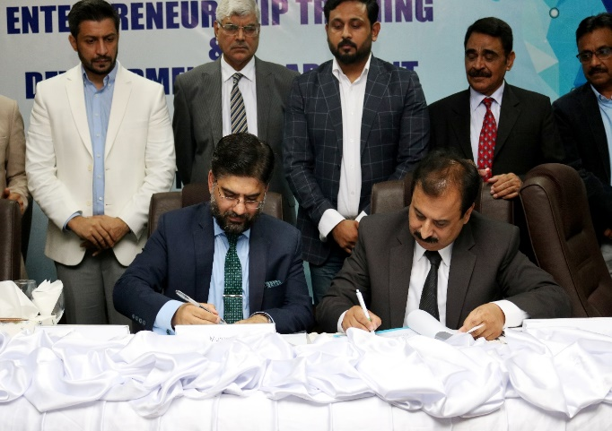 | 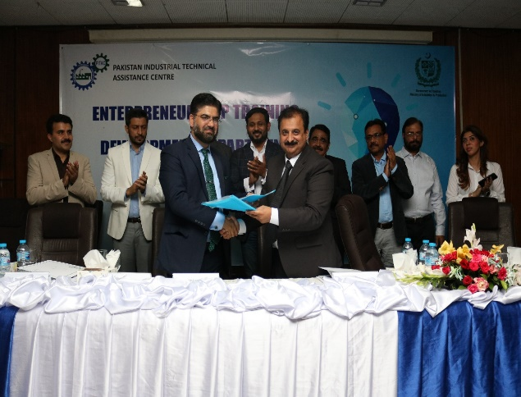
Entrepreneurship Training and Development Department MoU Signing with CoE – CPEC | Dr. Shahid Rashid, ED CoE CPEC and Engr. Muhammad Irfan Zaheer DG PITAC
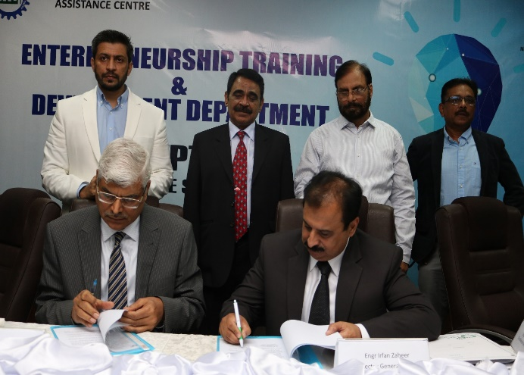 | 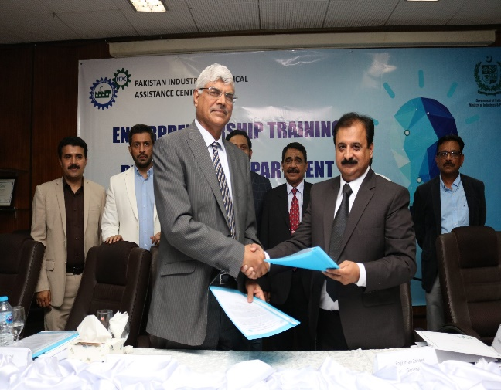
Entrepreneurship Training and Development Department MoU Signing with UMT | Dr. Muhammad Aslam, Rector UMT and Engr. Muhammad Irfan Zaheer DG PITAC

------------------------------------------------------

